Formatted Query with Variable, Join, Report Format
Thursday, August 5, 2021
2:56 PM
drop program 1_tr_med_service go
create program 1_tr_med_service

prompt
"Output to File/Printer/MINE" = "MINE" ;* Enter or select the printer or file name to send this report to.

with OUTDEV

/**************************************************************
; DVDev DECLARED SUBROUTINES
**************************************************************/

/**************************************************************
; DVDev DECLARED VARIABLES
**************************************************************/
declare MRN_VAR = f8 with Constant(uar_get_code_by("MEANING",319,"MRN")),protect

/**************************************************************
; DVDev Start Coding
**************************************************************/

; Your Code Goes Here
SELECT INTO $OUTDEV
P.NAME_FULL_FORMATTED
, E_MED_SERVICE_DISP = UAR_GET_CODE_DISPLAY(E.MED_SERVICE_CD)
, E.ENCNTR_ID
, E.REG_DT_TM
, E.DISCH_DT_TM
, E.REASON_FOR_VISIT
, EA.ALIAS
, EA_ENCNTR_ALIAS_TYPE_DISP = UAR_GET_CODE_DISPLAY(EA.ENCNTR_ALIAS_TYPE_CD)

FROM
PERSON P
, ENCOUNTER E
, ENCNTR_ALIAS EA

PLAN E where E.REG_DT_TM BETWEEN CNVTDATETIME("31-DEC-2019 23:59:59.00") AND CNVTDATETIME("31-DEC-2020 23:59:59.00")
JOIN P where p.person_id=e.person_id
JOIN EA where ea.encntr_id=e.encntr_id
AND ea.encntr_alias_type_cd=MRN_VAR

ORDER BY
E_MED_SERVICE_DISP DESC

HEAD REPORT
ROW 1 COL 56 "MEDICAL SERVICE REPORT"
;call center ("MEDICAL SERVICE REPORT", 0, 132)
ROW + 2
Head Page
COL 5 "REPORT DATE:"
COL 21 curdate
ROW + 2
COL 5 "MEDICAL SERVICE:"
COL 30 "FULL NAME"
COL 60 "MEDICAL RECORD NUMBER"
COL 88 "ADMISSION DATE"
COL 109 "DICHARGE DATE"
ROW + 2

Head e_med_service_disp
COL 5 E_MED_SERVICE_DISP

DETAIL IF((ROW+2)>= MAXROW) BREAK ENDIF

NAME = SUBSTRING(1,25,P.NAME_FULL_FORMATTED )
COL 29 NAME
ALIAS1 = SUBSTRING(1,15,EA.ALIAS )
COL 61 ALIAS1
COL 89 E.REG_DT_TM
COL 109 E.DISCH_DT_TM
ROW + 1

FOOT e_med_service_disp
COL 29 "MEDICAL SERVICE TOTAL:"
COL+2 COUNT(e.encntr_id) row+2

FOOT PAGE ROW MAXROW -1
COL 78 "PAGE:"
COL +2 CURPAGE "##"

FOOT REPORT
COL 56 "END OF REPORT"
;call center("END OF REPORT", 0, 132)

WITH MAXREC = 100, NOCOUNTER, SEPARATOR=" ", FORMAT

/**************************************************************
; DVDev DEFINED SUBROUTINES
**************************************************************/

end
go

Tables for Example Encounter
Thursday, July 29, 2021
11:46 AM
Admission
- ENCNTR_DOMAIN
  - Real-time view of where each patient is located
- PM_TRANSACTION
  - Log of the ATD transactions and related events (admission, transfer, discharge)
Orders
- ORDER_DETAIL
  - Systems treats each detail as a single entry with its own sequential number
- ORDER_ACTION
  - Tracks different actions that occur with each order (placed, modified, completed)
- ORDER_COMMENT
  - Updated when comment (ORDER_COMMENT_IND =1 from ORDER_ACTION) is associated to specific ORDER_ID
- LONG_TEXT
  - Full text of order comments. Joins to ORDER_COMMENT from LONG_TEXT_ID
Results
- CLINICAL_EVENT
  - Stores result-type data, main table for storing procedure information. Creates a new row for each component of an order (temp, BP, HR) with its own CLINICAL_EVENT_ID
- RESULT
  - Stores the details about the individual components of the ordered procedure, linked to ORDERS table with ORDER_ID
- PERFORM_RESULT
  - Updated when the results of a general lab procedure are verified. Stores results and related information such as normal result ranges. Linked to RESULT table by RESULT_ID
- RESULT_COMMENT
  - Updated when comment is added (COMMENT_IND from RESULT), then to LONG_TEXT linked by LONG_TEXT_ID
Discharge
- ENCNTR_DOMAIN
  - Updated with END_EFFECTIVE_DT_TM
- PM TRANSACTION
  - New TRANSACTION_ID row for the discharge of the patient
- ENCNTR_LOC_HIST
  - Stores location history for each encounter. Linked to ENCOUNTER by ENCNTR_ID

Intermediate WBT
1_tr_person_encounter
Thursday, August 12, 2021
8:01 AM
- Reasons for proprietary language (actually called Discern Explorer now)
  - RDBMS Independence
  - Implement functionality at a global level
  - Provides functionality not available at RDBMS level
- Discern Launch is a tool that houses a place to open many different Discern tools and only having to log in once
SELECT COMMAND
- 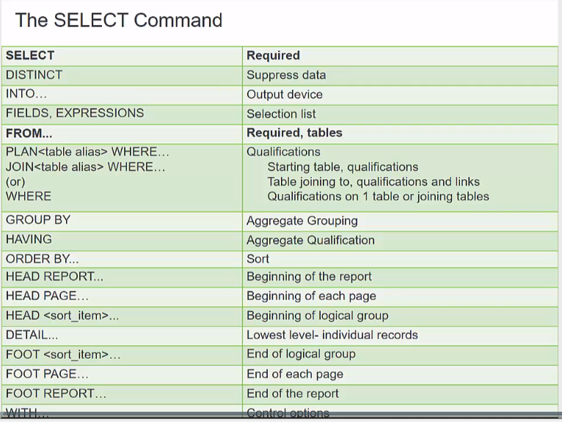
EXECUTABLE PROGRAM
- Purpose: 1) execute programs on demand, 2) execute programs from front end apps, 3) create a report style output, 4) accept information from a prompt or another program to flex output
Data Model Reports
- Data model is an entity relationship diagram that displays the tables and relationships
  - CCLGLOS
- Table report displays field types and columns
Joining Tables
- Composite Index: when there are multiple fields within an index. Use the rest of the indexes listed as additional qualifications (ex: date range for discharge date)

Reportwriter (Portrait pages are 60x132) (landscape is 48x170 or maxcol)
- 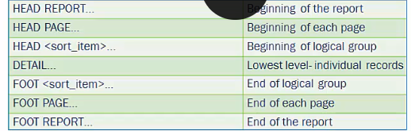
  - Every head needs a foot to go with it, can be accessed with Layout Builder
  - If there is an ORDER BY clause, the HEAD command will be sorted by it
    - FOOT sort item will also sort it by the end of the grouping.
    - If there is multiple lines for one person, it will display the name on the first line only and then you can place a "Number of rows" line on the footer line
    - Each HEAD SORT section must match the order of the ORDER BY clause if they are all used.
      - HEAD 1
      - HEAD 2
      - HEAD 3
      - DETAIL
      - FOOT 3
      - FOOT 2
      - FOOT 1
- 